CO2 Assessment 01 Date: 22-10-2026
ANALYTICAL PROBLEM SOLVING
Course Code: DSA0308
Course Name: Natural Language Processing
Register No: 192324299 Haritha S

- Input words: “connected”, “connecting”, “connection”, design a
morphological analysis pipeline for a document indexing system.
Explanation: Morphological analysis decomposes words into roots and suffixes and classifies suffixes as inflectional or derivational. The program normalizes connected, connecting, and connection to the common base form connect for efficient document retrieval.
Code:
words = ["connected", "connecting", "connection"]
rules = {
"ed": ("connect", "Inflectional"),
"ing": ("connect", "Inflectional"),
"ion": ("connect", "Derivational")
}
print("-" * 90)
print("MORPHOLOGICAL ANALYSIS PIPELINE")
print("-" * 90)

print(f"{'Word':<15}{'Root':<15}{'Suffix':<15}"
f"{'Suffix Type':<20}{'Normalized Form':<20}")
print("-" * 90)
for word in words:
if word == "connected":
root = "connect"
suffix = "ed"
suffix_type = "Inflectional"
elif word == "connecting":
root = "connect"
suffix = "ing"
suffix_type = "Inflectional"
elif word == "connection":
root = "connect"
suffix = "ion"
suffix_type = "Derivational"
normalized = root
print(f"{word:<15}{root:<15}{suffix:<15}"
f"{suffix_type:<20}{normalized:<20}")
print("-" * 90)
print("All words are normalized to the common base: connect")
Output:
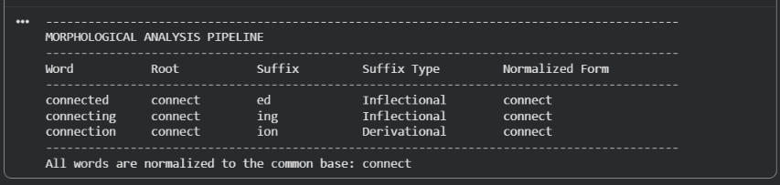
Result:
The program successfully decomposes the given words, classifies their suffixes, and normalizes all three words to the base form connect.
- Input words: “unhappy”, “happiness”, “happily”, design a morphological parsing module for sentiment analysis.
Explanation:
The program identifies prefixes and suffixes and extracts the common root happy. All three transformations are derivational because they create words with different meanings or grammatical functions.
Code:
words = ["unhappy", "happiness", "happily"]
print(f"{'Word':<12}{'Prefix':<12}{'Root':<12}"
f"{'Suffix':<12}{'Type':<18}{'Normalized Root'}")
print("-" * 85)

for word in words:
if word == "unhappy":
prefix, root, suffix = "un", "happy", ""
kind = "Derivational"
elif word == "happiness":
prefix, root, suffix = "", "happy", "ness"
kind = "Derivational"
elif word == "happily":
prefix, root, suffix = "", "happy", "ly"
kind = "Derivational"
print(f"{word:<12}{prefix:<12}{root:<12}"
f"{suffix:<12}{kind:<18}{root}")
Output:
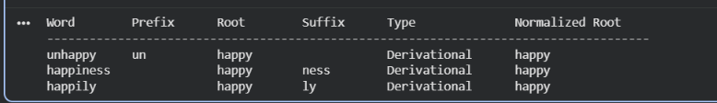
Result:
The morphological parsing module successfully identifies the morphological components and normalizes all three words to happy, supporting consistent word processing in sentiment analysis.

- Input words: “played”, “player”, “playing”, design a stemming-based preprocessing module for a search engine.
Expalnation:
The program removes the suffixes -ed, -er, and -ing to extract the common stem play. The suffixes -ed and -ing are inflectional, while -er is derivational because it forms the noun player.
Code:
words = ["played", "player", "playing"]

print(f"{'Word':<12}{'Stem':<12}{'Affix':<12}"
f"{'Type':<18}{'Normalized Form'}")
print("-" * 65)

for word in words:
if word == "played":
stem, affix, kind = "play", "ed", "Inflectional"
elif word == "player":
stem, affix, kind = "play", "er", "Derivational"
elif word == "playing":
stem, affix, kind = "play", "ing", "Inflectional"

print(f"{word:<12}{stem:<12}{affix:<12}"
f"{kind:<18}{stem}")
Output:
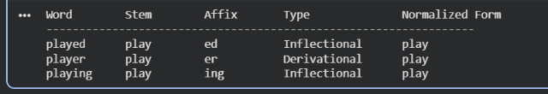
Result:
The stemming module successfully extracts the common stem play from all three words and generates normalized forms suitable for search engine indexing and information retrieval.
- Input words: “writes”, “writing”, “written”, design a finite-state morphological parsing module for a text processing system.
Explanation:
The finite-state parser follows transitions to identify the root, suffix, and word type. It handles writes and writing as regular forms and written as an irregular participle, normalizing all three to write.
Code:
words = ["writes", "writing", "written"]
transitions = {
"START": "CHECK_ROOT",
"CHECK_ROOT": "CHECK_SUFFIX",
"CHECK_SUFFIX": "NORMALIZE",
"NORMALIZE": "END"
}
morphology = {
"writes": ("write", "s", "Regular"),
"writing": ("write", "ing", "Regular"),
"written": ("write", "en (irregular form)", "Irregular")
}

for word in words:
root, affix, kind = morphology[word]
path = (
"START -> CHECK_ROOT -> CHECK_SUFFIX "
"-> NORMALIZE -> END"
)
print("\nWord:", word)
print("State Path:", path)
print("Root:", root)
print("Morphological Component:", affix)
print("Classification:", kind)
print("Normalized Form:", root)
Output:
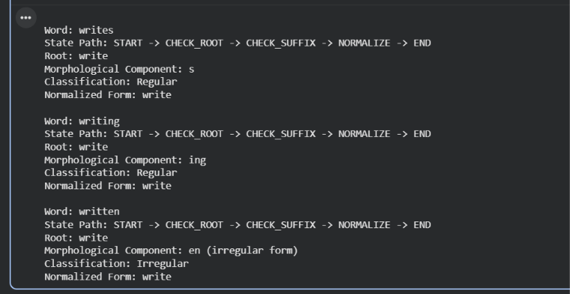
Result:
The program successfully demonstrates finite-state morphological parsing and normalizes all three input words to the common root write for text processing.

- Input words: “relational”, “relation”, “relate”, design a Porter Stemmer-based preprocessing module for document retrieval.
Explanation:
The Porter stemming process applies suffix-removal rules to reduce related words to a common stem. This helps a document retrieval system match different word forms during searches.
Code:
words = ["relational", "relation", "relate"]
def porter_stem(word):
steps = []

if word.endswith("ational"):
word = word[:-7] + "ate"
steps.append("ational -> ate (Step 2)")
elif word.endswith("tional"):
word = word[:-2]
steps.append("tional -> tion (Step 2)")

if word.endswith("ation"):
word = word[:-5] + "ate"
steps.append("ation -> ate")
elif word.endswith("ate"):
steps.append("No further suffix removal")
if word.endswith("e") and word not in ["be", "he"]:
word = word[:-1]
steps.append("Remove final e (Step 5)")
return word, steps
print(f"{'Original Word':<16}{'Applied Rules':<35}{'Final Stem'}")
print("-" * 75)
for original in words:
stem, steps = porter_stem(original)
print(f"{original:<16}{'; '.join(steps):<35}{stem}")
Output:
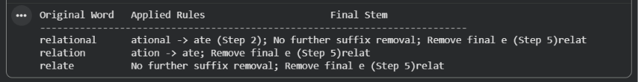
Result:
The program demonstrates rule-based stemming for the three input words and produces normalized stems for indexing. Note that this is a simplified demonstration of Porter stemming, not a complete implementation of the full Porter algorithm.

